**Test cases on login page of facebook**

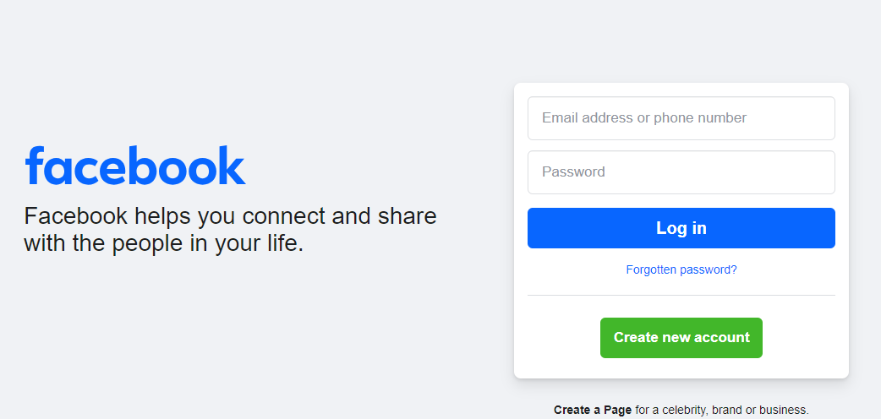

1. Verify the URL (https://www.facebook.com/) of the facebook login page.
2. Verify the logo of the facebook.
3. Verify the color, shape, size and position of the logo.
4. Verify the tagline.
5. Verify the color, position of the tagline.
6. Verify all the required labels, input fields, buttons, links, and text should be present.
7. Verify all the required labels, input fields, buttons, links, and text should be clearly visible.
8. Verify all the input fields, buttons, links, and text should be properly aligned.
9. Verify the placeholder is present or not.
10. Verify the navigation on forgot password link.
11. Verify the navigation on create account button.
12. Verify that user should be able to login with enter button.
13. Verify that user is able to enter username.
14. Verify that user is able to enter password.
15. Verify that password should be encrypted.
16. Verify the character limits of username field.
17. Verify the character limits of password field.
18. Verify the navigation of links present in footer section.
19. Verify that user should not able to login with blank username and password.
20. Verify that user should not able to login with blank username and valid password.
21. Verify that user should not able to login with valid username and blank password.
22. Verify that user should able to login with valid username and password.
23. Verify that user should not able to login with old password.
24. Verify that user should able to login with new password.
25. Verify that user cannot not set used password as new password.
26. Verify that user should not set username/email/phone number as password.
27. Verify that password should match expected criteria.
28. Verify the limit of unsuccessful login attempts allowed.